**CSE 458 Lab Final**

**Full Marks: 60 Time: 1 Hour**

1. **NUMBER** = Your registration number **MOD** 7

Modify the comparator code given in the classroom such that it has **3 inputs** and **1 output**. The three inputs represent a decimal value (from 0 to 7) and output is 1 if the value is greater than **NUMBER** else it is 0.

Test all 8 possibility in your testbench.

(check example at the bottom if you are confused).

**Upload the following to classroom**

* 1. Verilog code in .v format 5
  2. Testbench code in .v format 5
  3. Screenshot of the output in .png format 20

|  |  |  |
| --- | --- | --- |
| 2. | Consider the following function  Y = (A.B)+(C.D)   1. Draw Schematic of the function (upload handwriting by scan) 2. Draw Euler’s path of the function (upload handwriting by scan) 3. Draw Stick Diagram of the function (upload handwriting by scan) 4. Implement the design in Microwind (upload .msk file) | 5  5  5  15 |
|  | **Or** |  |
| 3. | Consider the following function  Y = (A+B).(C+D)   1. Draw Schematic of the function (upload handwriting by scan) 2. Draw Euler’s path of the function (upload handwriting by scan) 3. Draw Stick Diagram of the function (upload handwriting by scan) 4. Implement the design in Microwind (upload .msk file) | 5  5  5  15 |

Example of 1.

My registration number is 0000005

So, Number = 5

So, it will produce the following table:

|  |  |  |  |
| --- | --- | --- | --- |
| X | Y | Z | OUTPUT |
| 0 | 0 | 0 | 0 |
| 0 | 0 | 1 | 0 |
| 1 | 0 | 1 | 0 |
| 1 | 1 | 1 | 1 |
| 1 | 1 | 0 | 1 |

And so on …..

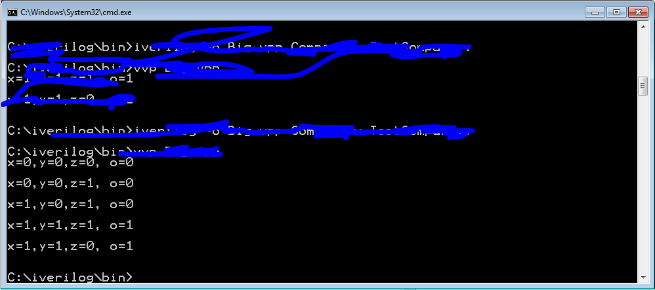

**You should test all 8 cases.**